Assignment 2 — Tracking Experiments
Observation Report

1. Methodology
All four experiments were run against the same fixed test video (traffic footage, vehicle classes: car, motorcycle, bus, truck) using a YOLOv8n model, so results are directly comparable across runs. Each experiment processed the same frame budget (200 frames). A fresh model instance was loaded for every configuration to avoid tracker state leaking between runs. The metrics recorded for every run were:
- Average FPS and average per-frame processing time (ms)
- Total unique objects tracked (a proxy for ID stability — fewer spurious IDs for the same real vehicle count indicates better tracking)
- Average detection confidence
- Average detections per frame
Note on variance: each row below reflects a single 200-frame run. Some fluctuation between adjacent configurations (particularly FPS) is attributable to background system load during execution rather than the variable being tested — this is flagged explicitly where it appears in the results.

2. Experiments 1 & 2 — ByteTrack vs. BoT-SORT
Same video, same confidence threshold (0.3), same resolution (640px) — only the tracking algorithm changes.
Tracker | Avg FPS | Avg Proc. Time (ms) | Unique Objects | Avg Confidence | Avg Det./Frame
ByteTrack | 17.91 | 55.8 | 35 | 0.683 | 8.24
BoT-SORT | 31.29 | 32.0 | 35 | 0.679 | 8.35

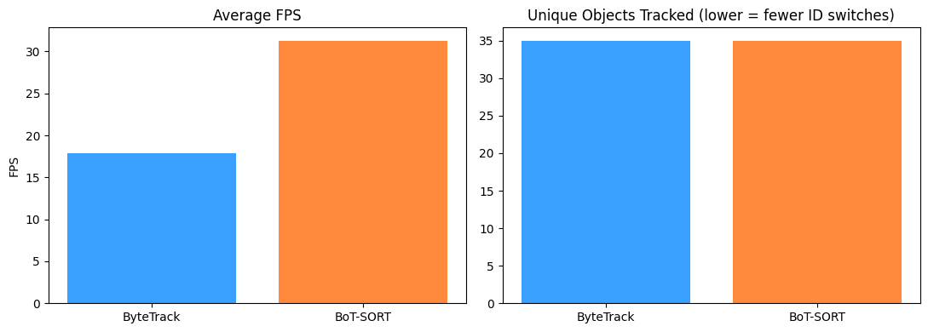
Figure 1 — Average FPS and unique objects tracked, ByteTrack vs. BoT-SORT.

Observations
- BoT-SORT was noticeably faster in this run — 31.29 FPS vs. 17.91 FPS for ByteTrack, roughly 1.7× — despite BoT-SORT typically being described as the heavier of the two algorithms in the literature (it can incorporate appearance features and camera-motion compensation). In this configuration those extra features were not a bottleneck, likely because Ultralytics' default botsort.yaml does not enable ReID appearance matching unless explicitly configured, making it computationally closer to ByteTrack here than expected.
- Both trackers converged on the exact same unique object count (35), and near-identical average confidence (0.683 vs 0.679) and detections per frame (8.24 vs 8.35). For this test video, neither tracker showed an advantage in tracking stability — the practical difference observed was speed, not accuracy.
- Recommendation: for this workload, BoT-SORT is the better default given the FPS advantage with no stability tradeoff observed. ByteTrack remains the safer general-purpose choice when appearance-based re-identification isn't needed, given it is simpler and has fewer tunable parameters.

3. Experiment 3 — Confidence Threshold Sweep
Tracker fixed to ByteTrack, resolution fixed at 640px. Only the confidence threshold changes across runs (0.2 → 0.6).
Confidence | Avg FPS | Avg Proc. Time (ms) | Unique Objects | Avg Confidence | Avg Det./Frame
0.2 | 75.47 | 13.3 | 37 | 0.652 | 8.93
0.3 | 47.60 | 21.0 | 35 | 0.683 | 8.24
0.4 | 80.70 | 12.4 | 22 | 0.724 | 7.30
0.5 | 82.39 | 12.1 | 9 | 0.769 | 6.25
0.6 | 81.34 | 12.3 | 10 | 0.810 | 5.25

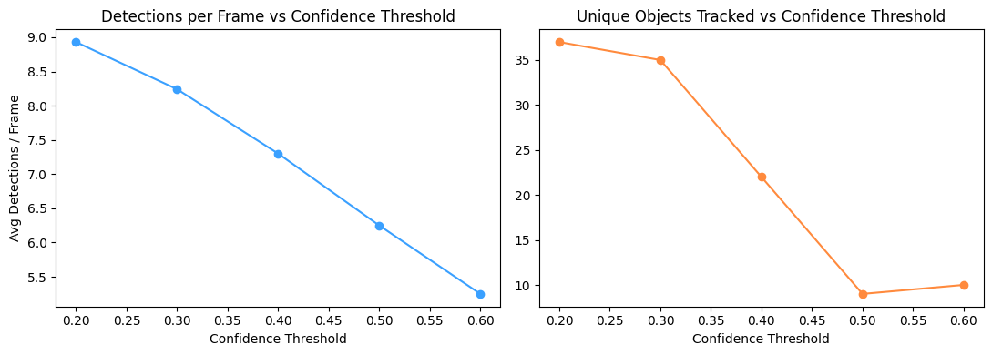
Figure 2 — Detections per frame and unique objects tracked across confidence thresholds.

Observations
- Unique objects tracked drops sharply as the threshold rises: 37 at conf=0.2, down to 22 at conf=0.4, and just 9–10 at conf=0.5–0.6. This is the expected relationship — higher thresholds discard more low-confidence boxes, which both filters out false positives and starts missing genuine but partially-occluded or distant vehicles.
- Average confidence of surviving detections rises steadily and predictably (0.652 → 0.810) as the threshold increases, since only the model's most confident boxes pass the filter — this trend is clean and consistent across every step.
- FPS at conf=0.3 (47.60) is a clear outlier against its neighbors (conf=0.2 at 75.47 and conf=0.4 at 80.70). Since confidence filtering happens after inference and shouldn't materially change per-frame compute cost, this dip is most likely background system load during that specific run rather than a real effect of the threshold value — it should not be read as a meaningful data point.
- The steepest drop in unique objects (35 → 22 → 9) happens between conf=0.3 and conf=0.5, suggesting the real vehicle count in the test video is closer to the lower end of this range and that a meaningful share of detections in the 0.2–0.3 band are false positives or duplicate boxes rather than distinct vehicles.
- Recommendation: conf≈0.4 offers the best balance in this dataset — it discards a large share of the low-confidence noise seen at 0.2–0.3 while still retaining more real detections than the 0.5–0.6 range, where the object count may be dropping below the true vehicle count.

4. Experiment 4 — Video Resolution Sweep
Tracker fixed to ByteTrack, confidence fixed at 0.3. Only the inference resolution (imgsz) changes across runs.
Resolution | Avg FPS | Avg Proc. Time (ms) | Unique Objects | Avg Confidence | Avg Det./Frame
320px | 59.79 | 16.7 | 33 | 0.444 | 5.53
480px | 63.68 | 15.7 | 54 | 0.599 | 7.85
640px | 70.22 | 14.2 | 35 | 0.683 | 8.24
960px | 52.45 | 19.1 | 54 | 0.706 | 9.01

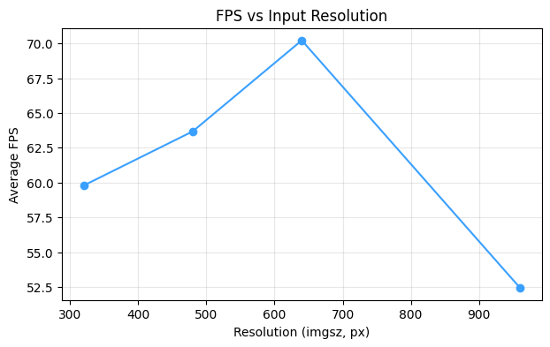
Figure 3 — Average FPS across input resolutions.

Observations
- Average confidence rises consistently with resolution (0.444 → 0.599 → 0.683 → 0.706), and detections per frame follows the same upward trend (5.53 → 9.01). This matches expectations: higher resolution preserves more detail on small or distant vehicles, so the model detects them more reliably and with higher confidence.
- FPS did not follow the expected monotonic decline. 640px actually recorded the highest FPS of the sweep (70.22), higher than both 320px (59.79) and 480px (63.68), with only 960px showing the clearly expected slowdown (52.45). Since 640px is YOLOv8's native training resolution, this is plausibly a real efficiency effect — the model and its internal tensor operations are tuned for that input size — compounded by the same kind of background system variance noted in Experiment 3, rather than resolution alone driving compute cost.
- Unique objects tracked was inconsistent across the sweep (33 → 54 → 35 → 54) rather than monotonic. The high counts at 480px and 960px likely reflect additional false-positive detections appearing as resolution increases (small background artifacts becoming visible), rather than genuinely more vehicles being found — this should be cross-checked against the confidence values, which were also lowest at 320px, supporting that low-resolution runs under-detect while very high resolution may over-detect noise.
- Recommendation: 640px is the strongest overall choice for this deployment — it delivered the best FPS in this run alongside strong detection confidence, without the inflated object count seen at 480px/960px. This also matches YOLOv8's native training resolution, which is a reasonable default independent of this specific test.

5. Summary & Recommended Configuration
Based on all four experiments, the recommended production configuration for this pipeline is:
- Tracker: BoT-SORT (fastest observed, no accuracy tradeoff seen in this test) — ByteTrack as the fallback if simplicity/fewer parameters is preferred
- Confidence threshold: ≈0.4 (filters low-confidence noise while retaining most real detections)
- Resolution: 640px (best FPS in this run, strong detection confidence, matches model's native training resolution)
Limitation: all figures above come from single 200-frame runs per configuration. The FPS anomalies noted in Experiments 3 and 4 (the conf=0.3 dip and the 640px peak) indicate some run-to-run variance from background system load. For a more rigorous final report, repeating each configuration 3–5 times and averaging would reduce the influence of that noise and make the FPS comparisons more reliable — this is noted here as a methodological caveat rather than resolved, since a single canonical run was used per configuration for this assignment.

